Additional Description for the Threatened Network
Updated 4/10/2012

Overview

Setting: A regional office of Bank of Money, which has recently been reconfigured and transitioned to 24-hour operation to support its added function as a call center.
Summary: A regional office of the Bank of Money is experiencing difficulties with its computing infrastructure.
There are reports from some staff members that unwanted messages are appearing on their monitors, informing them that their workstations are infected with spyware and viruses. These messages do not appear to be coming from the standard Bank of Money virus protection. Instead, they look more like ad-ware. The messages pop up repeatedly during computer use. These ads look like the example shown in Figure 1.
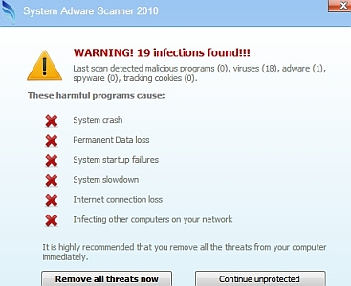
Figure 1. Example of pop-up warnings
Some users also report seeing an anti-virus program appear that seems to scan their workstations for viruses, but it is not clear whether this program is legitimate. The anti-virus program looks like the example shown in Figure 2.
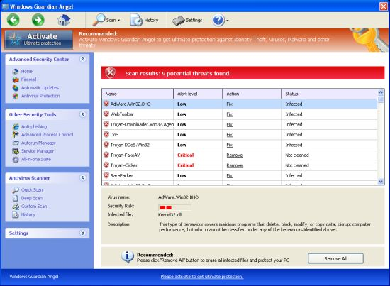
Figure 2. Suspicious virus scan program

Some staff members are also reporting that their systems seem to be running more slowly than normal and that the hard disk seems to always be running.

Network Configuration
The Bank of Money regional office network has been reconfigured to support the addition of call-center activity. The network configuration is illustrated in Figure 3. This Bank of Money regional office has been configured with approximately 4000 workstations and approximately 1000 servers. The office operates 24 hours a day. Some of the financial transactions are performed on financial servers inside the regional bank office’s network. Other financial transactions travel to the corporate headquarters datacenter. The Bank of Money regional office uses web-based mail which is housed in the corporate headquarters datacenter.
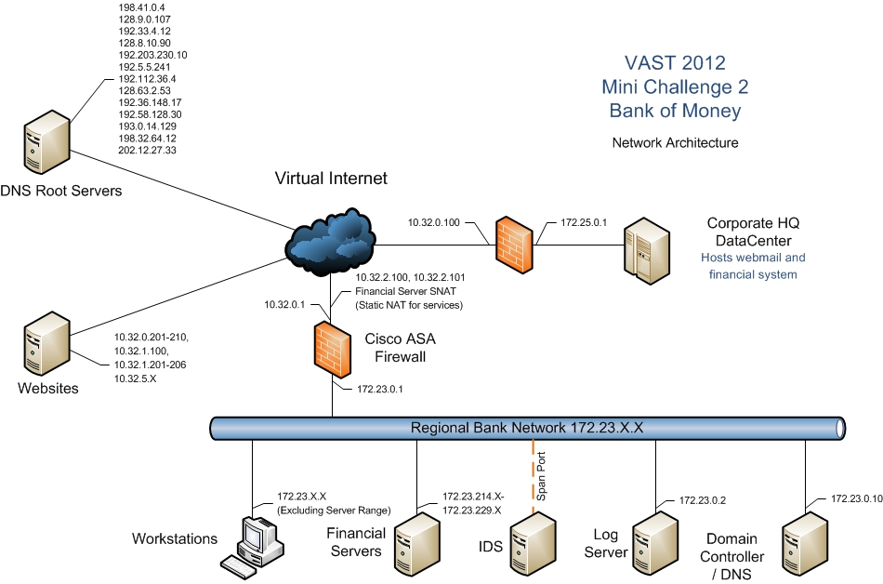
Figure 3. Bank of Money Regional Headquarters Network

The following notations are used in this document and associated network architecture diagram:
- Where an IP is described as 172.23.X.X, the X indicates that “X” can represent any number from 0-255.
- When an IP address is described as 10.32.0.201-210, this indicates that the IP will be one of a range from 10.32.0.201 through 10.32.0.210.
Certain nodes on the network are considered to be high priority nodes because they are critical to the overall operation of the Bank of Money's business. Other nodes are considered to be of average priority, because loss or damage to those nodes is less likely to be catastrophically disruptive to the company’s business. Bank of Money uses virtual machines throughout its network.
The nodes on the Bank of Money network are described in Table 1. Nodes outside the range 172.x.x.x should be considered external to the Bank of Money network.

Table 1. Nodes on the Bank of Money Regional Headquarters network
IP Address | Node Name | Node Type | Description | Priority (High or Normal)
10.32.0.1 |  | Firewall | Firewall interface to the Internet | High
172.23.0.1 |  | Firewall | Firewall interface to regional bank network | High
10.32.0.100 |  | Firewall | Corporate Headquarters DataCenter firewall interface to the Internet | High
172.25.0.1 |  | Firewall | Firewall interface to the Corporate Headquarters DataCenter, which houses the corporate web-based mail servers and financial systems | High
Multiple IPs |  | DNS Root Servers | Internet servers that translate host names into IP addresses
10.32.0.201-210; 10.32.1.100; 10.32.1.201-206;  10.32.5.1-254 |  | Websites | Internet web sites accessible by Bank of Money employees
10.99.99.2  (not seen in traffic) | IDS | Snort Intrusion Detection System | Snort IDS interface to the network | High
172.23.214.x through 172.23.229.x |  | Financial servers | Servers located at the Bank of Money regional office used for financial transaction processing. | High
172.23.0.10 | Domain controller / DNS |  | Server running critical network operations: domain controller and domain name server | High
172.23.0.2 |  | Log Server | Server that captures log entries from the firewall. | High
172.23.x.x (excluding those servers explicitly identified above) |  | Workstations | Individual computers located in offices or cubicles throughout Bank of Money | Normal

Common Ports and Their Usage
The following are common ports used on the Bank of Money network. For a complete list of ports, please refer to http://en.wikipedia.org/wiki/List_of_TCP_and_UDP_port_numbers
- Port 53 – domain name service (DNS)
- Port 80 – web traffic (HTTP)

Acceptable Use Policy
The following is the acceptable use policy established for the Bank of Money network. All company staff members have received training regarding acceptable use of the network.
- The Bank of Money computer network is to be used for business use only. Personal use of company computing resources is prohibited. Staff members may not use their company computers to access personal email, visit social networking or auction sites, or conduct personal banking activity.
- Employees cannot connect to the Bank of Money intranet from home or other remote locations. All remote access to the Bank of Money intranet is blocked, including FTP, telnet, remote login, and remote desktop connections. Thumb drives and other external memory devices not purchased and owned by Bank of Money cannot be used on company computers. Company-owned thumb drives and external memory that have been removed from company premises must be scanned by a system administrator upon return to the Bank of Money premises. No personally owned computers or devices may be used on the Bank of Money network.
- Only company-purchased and approved software may be installed on Bank of Money computers. Software must be installed by a system administrator. File-sharing software and peer-to-peer communications software are never permitted on Bank of Money computers.

Logs
The following logs are available from the Bank of Money network.
- Firewall log
The firewall for the Bank of Money Corporation is a Cisco Adaptive Security Appliance 5510. There are two firewall logs for the complete run, one per day. This data is captured in a comma-separated values (.csv) file, with the most recent entry at the bottom. An excerpt from the example file is shown in Figure 4. The types of data captured contained in each firewall record are:
- Date/Time – date and time when activity was performed.
- Logging Device - IP address of the Firewall log
- Syslog priority – the priority of the log message.
- Operation – type of activity being performed.
- Message code – code associated with the message.
- Protocol – connection protocol type.
- Source IP - source IP associated with the activity. This field may be left empty for some log messages.
- Source MAC Address - MAC address assigned to the machine associated with this activity.
- Destination IP – the destination IP associated with the activity. This field may be left empty for some log messages.
- Source port - port associated with the source IP in this activity. This field may be left empty for some log messages.
- Destination port - port associated with the destination IP for this activity. This field may be left empty for some log messages.
- Source side - either "inside" or "outside"
- Destination side - either "inside" or "outside"
- Destination service – name of the service associated with the destination port.
- Interface – this field is empty in this dataset.
- Direction - either "inbound" or "outbound"

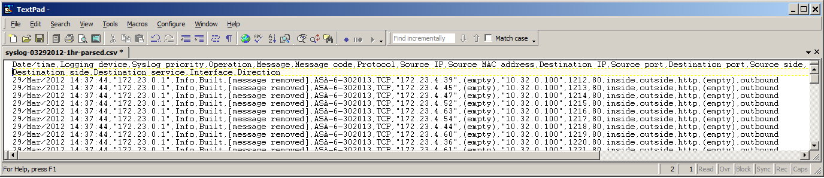

Figure 4. Firewall Log Excerpt

- Intrusion Detection System (IDS) logs
The Intrusion Detection System used by Bank of Money is Snort. Snort is a fully customizable IDS used to detect different types of network traffic. The system is currently configured with the Emerging Threats Ruleset. Emerging Threats is a popular open source Snort IDS rule set available online at http://rules.emergingthreats.net/open/snort-2.9.0/.

This dataset includes two IDS logs for the entire run, one per day.

Each log entry contains many details. If opened in WordPad, as shown in Figure 5, each log entry takes up to 6 lines and is followed by a blank line before the next entry. The important parts of a log entry are identified in Table 2. Here, the line number refers to the line number of the entry shown in the WordPad example.

Table 2. IDS File Content
Line # | Content / Format | Useful Content for this Challenge
1 | [**]  [Snort Rule File]  Text of specific rule violated  [**] | Text of specific rule violated
2 | [Classification: an optional generalized description of the alert] [Priority of the alert] | Classification (if present)  Priority
3 | Date/Time MM/DD-HH24:MI:SS.milliseconds  Source IP/Port  Destination IP/Port | Date/Time  Source IP/Port  Destination IP/Port
Remaining lines | No content used in the challenge | None

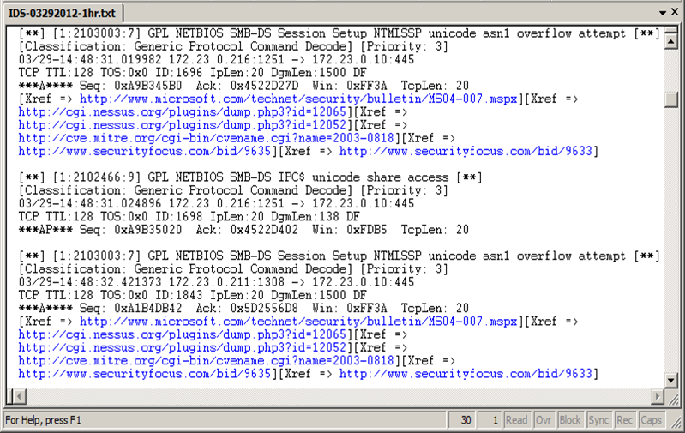

Figure 5. IDS alert excerpt
The intrusion detection alert file has also been parsed into a CSV-formatted file for convenience. It contains the following columns:

- time - value parsed from line 3 of the message block
- sourceIP - value parsed from line 3 of the message block
- sourcePort - value parsed from line 3 of the message block
- destIP - value parsed from line 3 of the message block
- destPort - value parsed from line 3 of the message block
- classification - value from the [Classification: …] field in line 2
- priority - value from the [Priority:… ] field in line 2
- label – value parsed from line 1 of the message block
- packet info - line 4 of the message block; contains IDS packet level information
- packet info cont’d - line 5 of the message block; contains IDS packet level information
- xref - Some records contain a block [Xref => <url>][Xref….], if it was provided by the IDS tool.

